

**Project:**

**1. 4-way Traffic Light control**

**Group Members:**

1. **Syed Muhammad Huzaifa(21k-4948) Leader**
2. **Talha Shahid(21k-3355)**

**Course Instructure: Miss Sadaf Ayesha**

**Components:**

1. **Breadboard**
2. **Wires**
3. **Led lights**
4. **555 Timmer**
5. **Cd4017 IC**

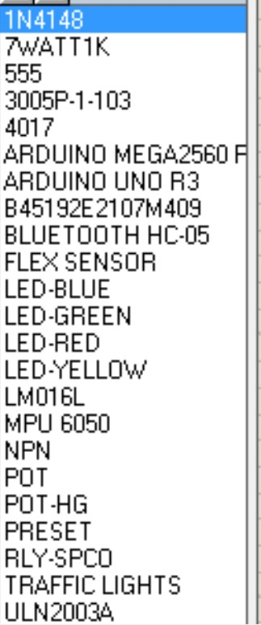

**Circuit Diagram:**

